OpenCV For Video Processing

# Task 1: Capture Video from Camera

## Often, we have to capture the live stream with a camera. OpenCV provides a very simple interface to this. Let’s capture a video from the camera (I am using the in-built webcam of my laptop), convert it into grayscale video, and display it.

To capture a video, you need to create a **VideoCapture** object. Its argument can be either the device index or the name of a video file. The device index is just the number to specify which camera. Normally one camera will be connected (as in my case). So I simply pass 0 (or -1). You can select the second camera by passing 1 and so on. After that, you can capture frame-by-frame. But in the end, don’t forget to release the capture. To read web cam will see the code.

# Task 2: Importing the required libraries.

## Install Twilio library, run the below command in anaconda prompt,

“pip install twilio”.

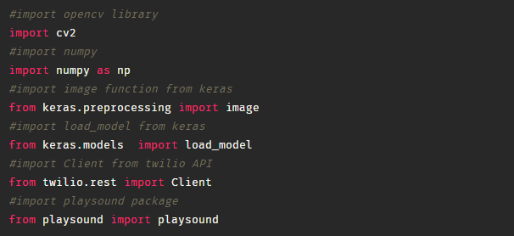

# Task 3: Loading our saved model file using load_model from Keras library

